Solve by gulshan

MIDTERM EXAMINATION
Spring 2009
MTH101- Calculus And Analytical Geometry (Session - 6)
Time: 60 min

Question No: 1 ( Marks: 1 ) - Please choose one
The set {…,-4,-3,-2,-1,0,1,2,3,4,..} is know as set of …………..

► Natural numbers
► Integers

► Whole numbers
► None of these

Question No: 2 ( Marks: 1 ) - Please choose one
The domain of the function
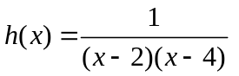 is

► 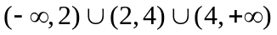
► 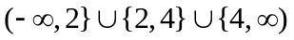
► 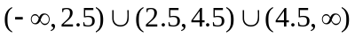
► All of these are incorrect

Question No: 3 ( Marks: 1 ) - Please choose one
If the
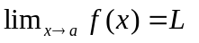then the inequality 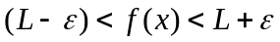 holds in any subset of the interval

► 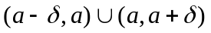
► 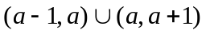
► 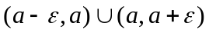
► None of these

Question No: 4 ( Marks: 1 ) - Please choose one
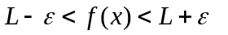 Can be written as

► 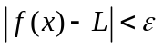
► 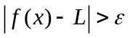
► 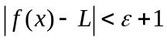
► None of these

Question No: 5 ( Marks: 1 ) - Please choose one
If a function satisfies the conditions

f(c) is defined
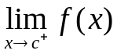 Exists
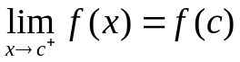
Then the function is said to be

► Continuous at c
► Continuous from left at c
► Continuous from right at c
► None of these

Question No: 6 ( Marks: 1 ) - Please choose one
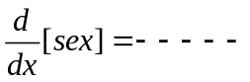

► 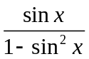
► 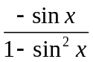
► 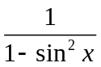
► None of these

Question No: 7 ( Marks: 1 ) - Please choose one
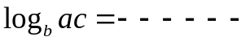

► 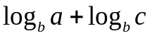
► 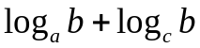
► 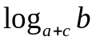
► None of these

Question No: 8 ( Marks: 1 ) - Please choose one
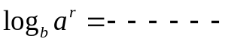

► 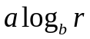
► 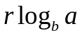
► 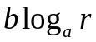
► None of these

Question No: 9 ( Marks: 1 ) - Please choose one
If
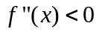on an open interval (a,b) then f is --------------- on (a,b )

► None of these
► Concave up
► Concave down
► Closed

Question No: 10 ( Marks: 1 ) - Please choose one
If f is a twice differentiable function at a stationary point
 and 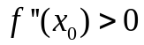 then f has relative …………. At

► Minima
► Maxima
► None of these

Question No: 11 ( Marks: 1 ) - Please choose one
A line is called a tangent line to the circle if it meets the circle at precisely ……………..

► One point
► Two points
► Infinite points
► None of these

Question No: 12 ( Marks: 1 ) - Please choose one
The equation
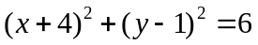 represents a circle having center at ……….. and radius ................

► 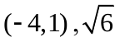
► 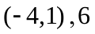
► 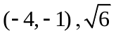
► None of these

Question No: 13 ( Marks: 1 ) - Please choose one
The
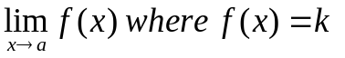(k is a constant) is equal to

► k+2
► k+1
► k
► kf

Question No: 14 ( Marks: 1 ) - Please choose one
For any polynomial
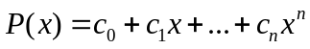 and any real number a 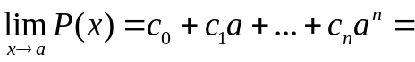

► 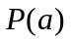
► 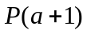
► 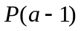
► 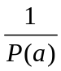

Question No: 15 ( Marks: 1 ) - Please choose one
Polynomials are always …………………. Function

► Continuous
► Discontinuous

Question No: 16 ( Marks: 1 ) - Please choose one
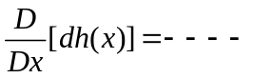 where is a constant

► 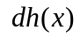
► 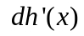
►
► None of these

Question No: 17 ( Marks: 1 ) - Please choose one
The graph
 is symmetric about

► X-axis
► Y-axis
► Origin
► None of these

Question No: 18 ( Marks: 1 ) - Please choose one
Consider two function
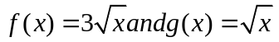 what is true about these functions

► 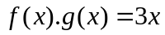
► 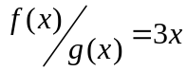
► 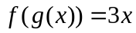
► None of these

Question No: 19 ( Marks: 1 ) - Please choose one
The formula
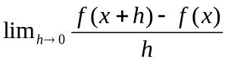 is called ……………….. with respect to x of the function f

► Derivative
► Slope
► Tangent
► None of these

Question No: 20 ( Marks: 1 ) - Please choose one
Suppose that
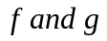 are differentiable function of x then 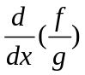

► 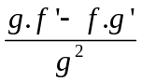
► 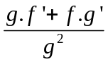
► 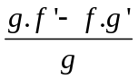
► None of these

Question No: 21 ( Marks: 2 )
If
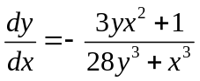then find the slope of the tangent line at the point (2, 0).

Question No: 22 ( Marks: 3 )
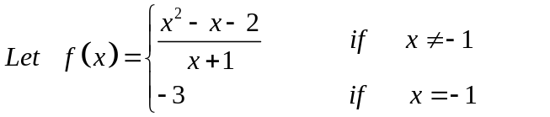
At what points the function is continuous and discontinuous? At point of discontinuity if any explain why it is discontinuous?

Question No: 23 ( Marks: 5 )
Differentiate w.r.t. x by chain rule
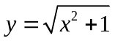

Question No: 24 ( Marks: 10 )
Evaluate the following limit


